ME 335L Mass Flowrate Worksheet
Names: Michael White, Joseph Massey, Alexander Kogut, Yiqiu Chen
Section #: 6 Group #: 3 Date: 3/10/2021
Relevant Equations: |  |  |  | Relevant Variables:
Area of A Circle: |  | $$A=πr^{2}$$ |  | $A$ = Area |  | $r$ = Radius
Mass Flow Rate: |  | $$\dot{m}=\int{ρvdA}≈\sum_{i=1}^{n}{ρv_{i}A_{i}}$$ |  | $ρ$ = Density |  | $n$ = Number of instances
 |  |  |  | $v$ = Velocity |  | $\dot{m}$ = Mass Flow Rate
Volumetric Flow Rate: |  | $$Q=vA$$ |  | $P$ = Pressure |  | $g$ = Gravitational Constant
Bernoulli Equation: |  | $$P_{1}+\frac{1}{2}ρ{v_{1}}^{2}+ρgh_{1}= P_{2}+\frac{1}{2}ρ{v_{2}}^{2}+ρgh_{2}$$ |  | $h$ = Height |  | $Q$ = Volumetric Flow Rate
1. | In your own words, what is mass flow rate measuring?
Mass flow rate is the amount of mass passing through a volume relative to time. Often, this is given as kilograms per second.
2. | Give an objective of this experiment (what is this experiment trying to show / find).
The objective is to calculate the mass flow rate of a fluid area from the velocity profile.

3. | Give a hypothesized outcome of the lab based on what you know about the system and procedure (what do you expect the results to look like, or how much error do you expect, or do you expect one value to be larger than another, or how do two things compare).
The velocity profile should be parabolic if fully developed, with there being no difference between the x-axis and the y-axis due to its concentric profile. Also, the Vmax (located in the center) should be twice the Vavg for this velocity profile. There is very little changing in this lab besides the position of the pitot tube, the pitot tube being used, and the axis location of the measurement. Therefore, there should be very little error.
4. | List all assumptions associated with the process and calculations. Spaces provided do not necessarily align with answers expected.
Velocity profile is fully developed |  |  | Newtonian Fluid |  | Steady-State flow
Inviscid fluid |  |  | Incompressible |  | Changes in elevation neglected
Laminar flow
5. | List all errors associated with the experiment (try not to include repeats of above). Spaces provided do not necessarily align with answers expected.
Calibration error |  |  | Pitot tube could change slightly in angle between measurements (depending on how far it is from the wall) |  | The velocity profile could be under-developed, meaning the velocity profile will not be a perfect parabola.
The density is calculated at the beginning and assumed not to change.
6. | Choose one of the errors and discuss how it would affect the final results of the experiment. (i.e. what calculations does it impact, if it has a directional impact would it increase or decrease your answer?)
If the velocity profile is underdeveloped, some of the measurements being taken could be inside the boundary layer. This means that there could be a central region where the velocity values appear flat (not parabolic). Depending on how late in the entrance region flow the measurements are taken, the sides of the tube may show parabolic tendency as they exposed more to the walls of the tube.

7. | Fill out the correct radii required for adjusting the location before getting approval to take data, then fill out the noticed locations as given by the LabView code as you run your experiment (just grab this for 1 trial).
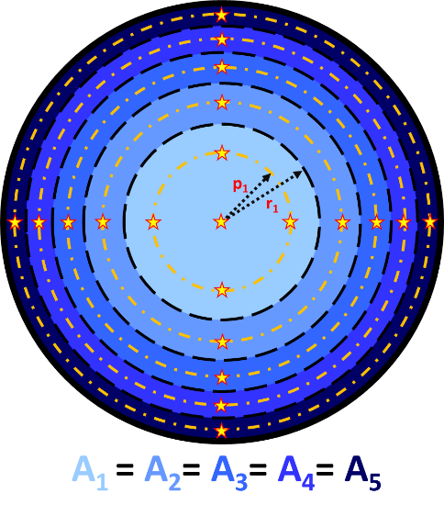 |  |  | Measurement Radius by Calculation |  |  |  | Measurement Radius by LabView Control
 |  |  | p₁ = |  | 0.9590 |  | p₁ = |  | 0.94
 |  |  | p₂ = |  | 1.6610 |  | p₂ = |  | 1.65
 |  |  | p₃ = |  | 2.1443 |  | p₃ = |  | 2.13
 |  |  | p₄ = |  | 2.5372 |  | p₄ = |  | 2.52
 |  |  | p₅ = |  | 2.8769 |  | p₅ = |  | 2.87
8. | Fill out the average velocity experienced in the wind tunnel for each condition. The wind tunnel provides what is approximately a uniform flow velocity throughout the entire test section of the tunnel. Assuming this, calculate the volumetric flow rate and mass flow rate for each condition.
Wind Tunnel Setting |  | Velocity (m/s) |  |  |  | Volumetric Flow Rate (m^3/s) |  |  |  | Mass Flow Rate (kg/s)
40% |  | 4.91591959 |  |  |  | 0.09162719 |  |  |  | 0.10271408
60% |  | 7.33574964 |  |  |  | 0.1373008 |  |  |  | 0.15327442
80% |  | 9.76888182 |  |  |  | 0.18208092 |  |  |  | 0.20411271
100% |  | 12.3727073 |  |  |  | 0.23061328 |  |  |  | 0.25851749
9. | Review or start the calculations for determining the mass flow rate in the cylinder. Which recorded velocity position is NOT used in the mass flow rate calculation?
We want to avoid using just the velocity at the center position. Instead, we want to use V_avg because the velocity profile is not flat. This allows us to calculate the mass flow rate throughout the tube.

